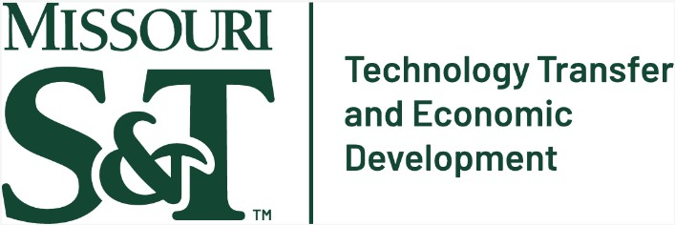
Entrepreneurship Day at Missouri S&T
Location: Innovation Lab 115 Date: November 18th, 2024
Time: 10 a.m. to 2:30 p.m.

Agenda

10:00 a.m. Welcome from Missouri S&T / Technology Commercialization Pathways
Dr. Timothy Faley, Associate Vice Chancellor of Innovation, Entrepreneurship, and Commercialization

10:30 a.m. Faculty experience: Startups
Dr. Frank Liou, Michael and Joyce Bytnar Product Innovation and Creativity Professor, Mechanical Engineering
Director, Intelligent Systems Center
Director, Manufacturing Engineering Program

10:45 a.m. Faculty Experience: Licensing
Dr. Fatih Dogan, Professor, Materials Science and Engineering

11:00 a.m. Faculty Experience: Research to Commercialization Transition
Dr. Fateme Fayyazbakhsh, Assistant Research Professor, Mechanical and Aerospace Engineering

11:15 a.m. S&T Research Growth / Importance of Tech Commercialization Dr. Kamal Khayat, Vice Chancellor for Research and Innovation Vernon and Maralee Jones Endowed Professor of Civil Engineering

11:30 a.m. Intellectual Property Protection
John Woodson, Associate Director of Technology Transfer & Economic Development

12:00 noon Lunch

12:30 p.m. Early-stage startup funding: Faculty SBIR experience
Dr. Pourya Shamsi, Associate Professor, Electrical and Computer Engineering Faculty Fellow, Office of Vice Chancellor of Research and Innovation

1:00 p.m. Regional Entrepreneurial Ecosystem
Dr. Venkat Allada, Professor, Engineering Management and Systems Engineering Executive Director of the Innovation Ecosystem Design Initiative

1:30 p.m. Discussion Panel: Dean’s perspective of tech commercialization
Topic: Entrepreneurship and Faculty Recognition
Moderator:
- Dr. Cassie Elrod, Chair, Business and Information Technology
Panelists:
- Dr. Mehrzad Boroujerdi, Vice Provost and Dean, College of Arts, Sciences, and Education

- Dr. David Borrok, Vice Provost and Dean, College of Engineering and Computing
- Dr. Jim Sterling, Vice Provost and Founding Dean, Kummer College of Innovation, Entrepreneurship, and Economic Development

2:00 p.m. Closing Remarks from the Chancellor
Dr. Mohammad Dehghani, Chancellor, Missouri University of Science and Technology

